**Analysis of Factors Affecting Student Performance**

**Muhammad Talha Akram**  
**Student ID: 23120527**

**GitHub Repository:**

**Introduction**

In this report, I looked at a dataset called "Student Performance Factors" to see how different factors might affect students' exam scores. The dataset includes things like hours studied, attendance, parental involvement, access to resources, and more.

**Descriptive Statistics**

Here are some basic statistics from the dataset to give an overview:

|  |  |  |  |
| --- | --- | --- | --- |
| **Factor** | **Average** | **Minimum** | **Maximum** |
| **Hours Studied** | 19.98 | 1 | 44 |
| **Attendance** | 79.98 | 60 | 100 |
| **Sleep Hours** | 7.03 | 4 | 10 |
| **Previous Scores** | 75.07 | 50 | 100 |
| **Exam Score** | 67.24 | 55 | 101 |

**Visualizations and Analysis**

**1. Correlation Matrix Heatmap**

The correlation matrix shows how different factors relate to each other. Here are some interesting points:

* **Hours Studied** has a positive correlation (0.45) with **Exam Score**.
* **Attendance** shows a stronger correlation (0.58) with **Exam Score** than study hours.
* **Previous Scores** have a small correlation (0.18) with **Exam Score**
* 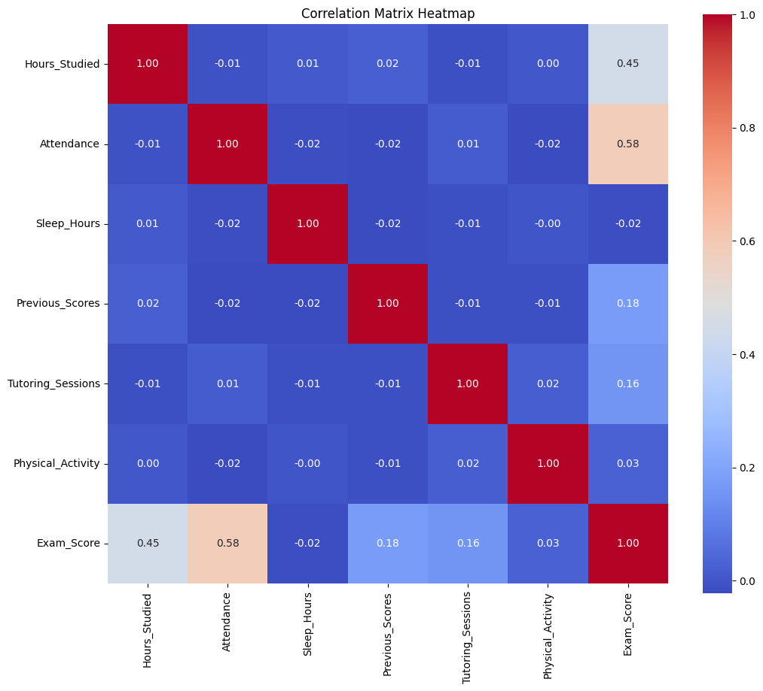

Figure 1Correlation Matrix

**2. Bar Chart of Exam Scores by Hours Studied**

The bar chart helps us see how **Hours Studied** affects **Exam Scores**.

Figure 2Bar Chart.

However, after about 30-35 hours, there doesn’t seem to be much additional benefit. This suggests that while studying is important, there might be a "sweet spot" where studying more doesn’t necessarily lead to higher scores.

**3. Scatter Plot of Exam Scores vs Attendance**

The scatter plot shows the relationship between **Attendance** and **Exam Scores**. There’s a noticeable trend where students with higher attendance scores (above 85%) generally have better exam scores. Most of the students who scored over 70 on their exams had high attendance. This implies that being present in class might help students perform better on exams.

**Conclusion**

From this analysis, it looks like **attendance** and **hours studied** are key factors that impact student performance. Students with higher attendance and a reasonable amount of study hours tend to perform better. However, studying excessively doesn’t necessarily result in higher scores, suggesting that quality of study time might be more important than quantity. Overall, focusing on consistent attendance and effective study habits could be beneficial for students aiming to improve their exam scores.